Study checklist MRI

Contact subjects in advance:
o Patient information of study project with behavioral conditions & fMRI criteria.
o Screening (subject MRI compatible? inclusion criteria?)
o Arrangement of appointment, possibility of contact by e-mail or telephone?
o Communication about the amount of compensation
Preparation:
o Get materials needed for the study (e.g. earplugs).
o Get MRI key
o Study book and measurement protocol ( + MRI information/consent form IZKF)
o Clarify who MR physician is on call (for emergencies).
Set-up in the MRI control room:
o Stimuli Box: turn on all toggle switches.
o Open the stimulation software on the PC, the PCs should always be switched on.
o Check entry in the study logbook/patient list on the syngo that no subject no. is assigned twice
o B-MRI: Check photo (use your own photo with your specific set-up here)

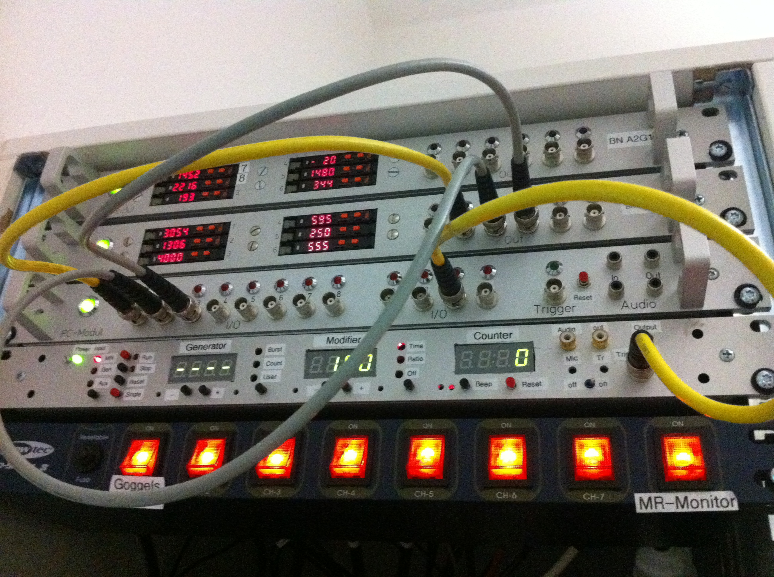

o Generator: MR must light up red, otherwise switch over: Test connection between scanner and PC1 (black small button above PCs on "single" then scanner sends a pulse), then set to "MR" via black button.
o Press the reset button once
o Test button box signals/check on generator
o Possibly set up and test physiological measuring devices
Preparing the participant:
o Ask subjects to go to restroom, discard anything metal (possibly metal detector).
o Verbal clarification of study project + MRI clarification
o Risks of fMRI (incidental findings clarification)
o Participant info/consent/data protection (copy of consent for subject).

MRI:
o If MRI has not yet started up: Get the key from the key box in the MR control room, insert it into the MR control panel and turn it, press ON, start the PC for the scanner, start-up takes approx. 15 min.
o Unlock MR room (key also in key box)
o Bring the screen behind the MRT into position, switch on
o Paper for the patient couch under the sink
o Register patient (subject number, no name), specify measurement license holder as assistant
o Select sequences from the USER tree - drag and drop them in
o Position subject ->, earplugs+headphones, elevate legs+arms, possibly cover if lightly clothed
o Avoid cable loops, avoid conductor loops
o Explain emergency alarm
o Is the mirror seated correctly?
o Attach coil, adjust laser to the root of the nose, drive in

Cleanup in the MRI room:
o Immediately take the participant out of the room after the scan is finished
o Subject receipt - Excel spreadsheet/cash register: signature
o Enter helium level in MRI logbook
o Disinfect head coil and headphones and change paper
o Clear study material out of MRI room if necessary
o Move monitor to the side and switch off toggle switch on power supply unit
o Lock the scanner door and return the key to the key box.

Cleanup in the MRI control room:
o Close the tab of the subject in Syngo
o Save data
o Log out on the PC, do not switch off the PCs!
o Switch off all toggle switches on the Stimuli Box
o Check logbook entry
o Lock the key box
o Clean up the MRI control room
o Doors should all be locked when leaving the room - check.
o Return MRI key

